Summary of the 2007-2009 Growth Policy Actions

Transportation:

Policy Area Mobility Review (applies to any subdivision filed after January 1, 2007 but not approved by November 13, 2007)

- An area-wide transportation test is re-introduced: Policy Area Mobility Review (PAMR), which evaluates relative arterial mobility (RAM) and relative transit mobility (RTM).
- RAM is the relative speed in a policy area by which auto trips move during the PM peak hour, compared to the free flow speed. RTM is the relative speed by which journey to work trips can be made by transit, compared to by auto. The RAM and RTM calculations are based on traffic generated by existing and pipeline development on a transportation network on the ground 4 years in the future: currently, by the end of FY 2011. Each policy area has an RAM and RTM score. The Council adopted standards based a relationship between RAM and RTM - see the PAMR chart below); generally the greater the RTM, the lesser the RAM is acceptable.

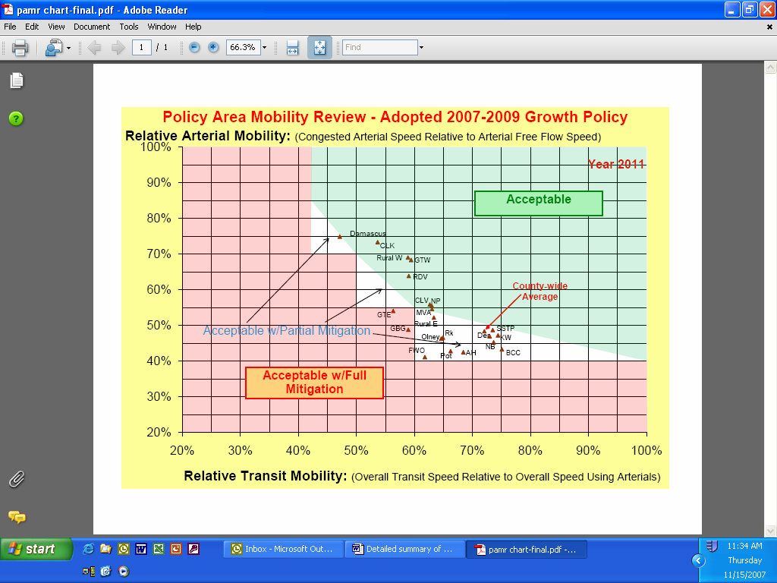

- If a policy area’s combined RAM/RTM score falls ‘below’ the stair-steps as outlined in the PAMR chart, then a new development may receive subdivision approval only if the developer mitigates trip-making at least equal to the trips the development would generate (i.e., 100% mitigation). Under current conditions, full mitigation would be required for development in 2 policy areas: the Germantown East policy area and the non-municipal part of the Gaithersburg policy area.
- If the policy area’s score falls into one of the triangular areas of the chart—that is, it approaches the 100% mitigation threshold—than partial mitigation is required, depending on how close the combined scores are to either the diagonal line (as low as 5% mitigation) or the stair-step (as high as 45% mitigation).

Under current conditions, 21 policy areas must partially mitigate their trips, as follows:

Damascus; Derwood (& Shady Grove MSPA); Rural East: 5%
Kensington/Wheaton (& Wheaton CBD & Glenmont MSPAs): 10%
Silver Spring/Takoma Park (& Silver Spring CBD MSPA): 15%
Olney, North Bethesda (&Grosvenor, White Flint, & Twinbrook MSPAs);non-municipal part of Rockville: 25%
Bethesda/Chevy Chase (& Friendship Hts. & Bethesda CBD MSPAs): 30%
Aspen Hill; Potomac: 40%
Fairland/White Oak: 45%

- Mitigation can be achieved 4 ways:
(1) through a trip reduction program under a binding Trip Mitigation Agreement;
(2) by providing non-auto facilities, such as bus shelters, segments of bikeways or sidewalks, and other specified means to enhance walking, biking, and transit ridership;
(3) by building or widening master-planned road segments in the policy area, in the amounts indicated in Table 2 (attached); and/or
(4) buying one or more full-size, hybrid-electric Ride On buses and operating them for at least 12 years (each bus mitigates 30 trips).

- The PAMR test does not apply to any subdivision generating 3 or fewer peak-hour trips.

Local Area Transportation Review (applies to any subdivision filed after January 1, 2007 but not approved by November 13, 2007)

- The Local Area Transportation Review (LATR) intersection congestion standards in 12 policy areas are tightened by 25 Critical Lane Volume (CLV) and in the Damascus, Rural East, and Rural West policy areas by 50 CLV. The standard in the Germantown Town Center policy area is loosened by 150 CLV. The changes are displayed in Table 1 below.

Table 1: Local Area Transportation Review
Intersection Congestion Standards

1350 | Rural East
1350 | Rural West
1400 | Damascus
1425 | Clarksburg
1425 | Gaithersburg
1425 | Germantown East
1425 | Germantown West
1425 | Montgomery Village/Airpark
1450 | Cloverly
1450 | North Potomac
1450 | Olney
1450 | Potomac
1450 | R & D Village
1475 | Aspen Hill
1475 | Derwood
1475 | Fairland/White Oak
1500 | Rockville City
1550 | North Bethesda
1600 | Bethesda/Chevy Chase
1600 | Kensington/Wheaton
1600 | Germantown Town Center
1600 | Silver Spring/Takoma Park
1800 | Bethesda CBD
1800 | Friendship Heights CBD
1800 | Glenmont
1800 | Grosvenor
1800 | Rockville Town Center
1800 | Shady Grove
1800 | Silver Spring CBD
1800 | Twinbrook
1800 | Wheaton CBD
1800 | White Flint

- The minimum scope of the LATR studies is increased for larger developments, as shown below:
Maximum Peak-Hour Trips  Generated | Minimum Signalized Intersections  in Each Direction
< 250 | 1
250 – 749 | 2
750 – 1,249 | 3
1,250 – 1,750 | 4
1,750 – 2,249 | 5
2,250 – 2,749 | 6
>2,750 | 7

- If a subdivision affects an intersection or roadway link for which congestion is already unacceptable, the subdivision may only be approved if the applicant agrees to mitigate either a sufficient number of trips to bring the intersection or link to acceptable levels of congestion or a number of trips equal to 150 percent of the CLV impact attributable to the development.
- For LATR, in addition to the CLV analysis, the Planning Board may now require queuing analysis wherever appropriate.

- Under the Alternative Review Procedure for Metro Station Policy Areas, the required impact tax payment is reduced to 75% (from 100%) of the applicable General District rate. This Procedure is now an alternative to both the PAMR and LATR tests.

Schools:

School adequacy test (applies to any subdivision filed after January 1, 2007 but not approved by November 13, 2007)

- The definition of capacity is MCPS program capacity in a high school cluster and at each level: elementary, middle, and high. The practice of ‘borrowing’ excess capacity from adjacent clusters at the high school level is eliminated. (Borrowing at the middle and elementary school levels was eliminated in the 2003-2005 Growth Policy.)
- A cluster goes into a residential moratorium if its enrollment 5 years from now would exceed 120% of cluster-wide program capacity at any level. Under current conditions, residential development in the Clarksburg, Einstein, and Kennedy clusters are in moratorium.

- A residential subdivision is required to make a School Facilities Payment if its enrollment 5 years from now would exceed 105% of cluster-wide program capacity at any level but would be less than 120%. Under current conditions, residential development in 9 clusters will require a School Facilities Payment to proceed: B-CC, Blake, Richard Montgomery, Northwest, Quince Orchard, Rockville, Wheaton, Whitman, and Wootton. (Parts of some clusters are located in Rockville or Gaithersburg, where different school adequacy requirements apply.)
- The School Facilities Payment is increased from $12,500/student (at any level) to $19,514 per/ES student, $25,411/MS student, and $28,501 per HS student. The costs per unit type are below:

Cost per unit by housing type | Elementary | Middle | High
Single-family detached | $6,245 | $3,659 | $3,734
Single-family attached | $4,118 | $3,100 | $3,050
Multi-family garden apt. | $2,986 | $1,423 | $2,081
High-rise; low-rise w/structured parking | $820 | $991 | $941

- The concept of ceilings is introduced in the school adequacy test. If a subdivision would cause a cluster to exceed the 120% threshold at any level, only the number of dwelling units that would reach the threshold would be allowed. Similarly, if a subdivision would cause a cluster to exceed the 105% threshold at any level, then the number of dwelling units which would exceed the threshold would make a School Facilities Payment to proceed to approval.
- Subdivisions of 3 units or fewer are exempt from the test, as is senior housing. The School Facilities Payment is waived in an enterprise zone (Wheaton CBD and Long Branch) or an area that was formerly an enterprise zone (Silver Spring CBD).

- In a cluster under residential moratorium, a subdivision of 3 or fewer units may proceed. A school facilities will be charged on each dwelling unit constructed, and will be charged at each level that exceeds 105% of program capacity.

School Impact Tax (changes effective December 1, 2007)

- The old and new base rates are shown below:
Housing Category | Old | New
Single-family detached | $9,111 | $20,456
Single-family attached | $6,833 | $15,401
Multi-family (except high-rise) | $4,555 | $9,734
Multi-family high rise | $1,822 | $4,127
Multi-family senior | $0 | $0

- The rates will be adjusted on July 1 in each odd-numbered year according to the change in a construction cost index to be specified by regulation. Previously this adjustment was based on the change in the consumer price index.
- The large single-family-dwelling surtax increases from $1/sf to $2/sf. The surtax applies to houses from 3,500 sf (rather than 4,500 sf) to 8,500 sf.
- For residential developments with 30% or more affordable housing units (moderately priced dwelling units and units for lower income-eligible residents), the market rate units are charged 50% of the applicable rate.

Transportation Impact Tax (changes effective December 1, 2007)

- The transportation impact tax rates are increased by 70% across the board. The old and new rates are shown below:
 | General  District |  | Metro Station Areas |  | Clarksburg  District
 | Old | New | Old | New | Old | New
Residential (per d.u.)
Single-family detached | $6,264 | $10,649 | $3,132 | $5,325 | $9,396 | $15,973
Single-family attached | $5,125 | $8,713 | $2,563 | $4,357 | $7,688 | $13,070
Garden apartments | $3,986 | $6,776 | $1,993 | $3,388 | $5,979 | $10,164
High-rise apartments | $2,847 | $4,840 | $1,424 | $2,420 | $4,271 | $7,261
Multi-family senior | $1,139 | $1,936 | $569 | $968 | $1,708 | $2,904
Non-residential (per sf)
Office | $5.70 | $9.69 | $2.85 | $4.85 | $6.85 | $11.65
Industrial | $2.85 | $4.85 | $1.40 | $2.43 | $3.40 | $5.78
Bioscience | $0.00 | $0.00 | $0.00 | $0.00 | $0.00 | $0.00
Retail | $5.10 | $8.67 | $2.60 | $4.34 | $6.15 | $10.46
Place of Worship | $0.30 | $0.51 | $0.15 | $0.26 | $0.40 | $0.68
Private School | $0.45 | $0.77 | $0.20 | $0.39 | $0.60 | $1.02
Hospital | $0.00 | $0.00 | $0.00 | $0.00 | $0.00 | $0.00
Social Service Agencies | -- | $0.00 | -- | $0.00 | -- | $0.00
Other Non-Residential | $2.85 | $4.85 | $1.40 | $2.43 | $3.40 | $5.78

- The transportation impact tax for any building within a half-mile of the following MARC commuter stations is levied at 85% of the applicable General District rate: Kensington, Garrett Park, Washington Grove, Gaithersburg, Metropolitan Grove, and Germantown.
- The rates will be adjusted on July 1 in each odd-numbered year according to the change in a construction cost index to be specified by regulation. Previously the rates were adjusted according to the change in the consumer price index.

