DRAFT
Montgomery County’s Rustic Roads Program Guidelines
Montgomery County, Maryland
Prepared by the Rustic Roads Advisory Committee
August 21, 2013

Montgomery County’s Rustic Roads Program Guidelines

This document was prepared by the members of the Rustic Roads Advisory Committee (RRAC). The current (August 21, 2013) members of the RRAC are:
Greg Deaver, Chairman and Engineer
Angela Butler, Farmer/Owner
Greg Glenn, Farmer
Robert N. Goldberg, Civic Association Representative (within the Agricultural Reserve), outgoing
Christopher H. Marston, Rural Preservation
Marc T. Miller, Civic Association Representative (outside of the Agricultural reserve)
Eric Spates, Farmer, Agricultural Advisory Committee representative
Jane Thompson, Civic Association Representative (within the Agricultural Reserve), incoming
Staff coordinator: Jay Beatty, Jr. (DPS)
Non-voting member: Leslie Saville (M-NCPPC)

This document was initiated by Kevin Foster, a committee member, and Sarah Navid, the committee’s former staff coordinator. The committee thanks both of them as well as the other committee members, staffers, and supporters who have provided invaluable assistance, including RRAC members Fred Lechlider and Robin Ziek, and Interim staff coordinator Laura Bradshaw.

The Montgomery County Department of Permitting Services provides staff to the RRAC. The committee can be contacted through their Staff coordinator:
Jay Beatty, 240-777-6340, Jay.Beatty@MontgomeryCountyMD.gov

The Maryland-National Capital Park and Planning Commission maintains a website for the Rustic Roads Functional Master Plans, and includes information about RRAC meetings and projects. The Rustic Roads website is:
http://www.montgomeryplanning.org/community/plan_areas/rural_area/rustic_roads.shtm

Contents

Purpose of this document 4
The Basis of the Rustic Roads Program 5
Criteria 6
Rustic Roads Advisory Committee 8
Program Summary 10
When to use the Guidelines 11
General Principles 12
Design Guidelines 14
1. The Roadway 14
1.a. Alignments and geometry 14
1.b. Roadway surface 14
1.c. Pavement cutting and utility work 15
1.d. Bridges and culverts 16
1.e. Grading and drainage 16
1.f. Driveways and intersections 16
1.g. Signs and markings 17
1.h. Bikeways 18
1.i. Curbs and gutters 19
1.j. Auxiliary lanes 19
1.k. Shoulders 19
2. The Edge 19
2.a. Driveways and intersections 19
2.b. Guardrails 20
2.c. Signs in the right-of-way 20
2.d. Speed cameras, utility boxes, etc. 20
2.e. Pedestrians and hikers 20
2.f. Equestrian users and equestrian trail crossings 21
2.g. Parking 21
2.h. Street trees 21
2.i. Informal hedgerows 22
2.j. Maintenance of roadside foliage and trees 23
3. The Land Beyond 24
3.a. Views and vista 24
3.b. Walls, fencing and mailboxes 25
3.c. Entry signs or features 25
3.d. Private signs 25
3.e. Screening 26
3.f. Cell towers, windmills, and wind turbines 26
Abbreviations/Bibliography 26

DRAFT
Montgomery County’s Rustic Roads Program
Guidelines

Montgomery County, Maryland
Prepared by the Rustic Roads Advisory Committee
Aug 20, 2013

Purpose of this document

The purpose of this document is to assist residents, consultants, agency staff, and others involved in projects and activities that impact Montgomery County’s rustic roads by providing a description of the program and guidance regarding the implementation of the program. The aim is that project and operational decisions regarding the County’s rustic roads can be made that will preserve, maintain, and enhance the character of these roads, and conform to the requirements of the County Code and associated regulations.
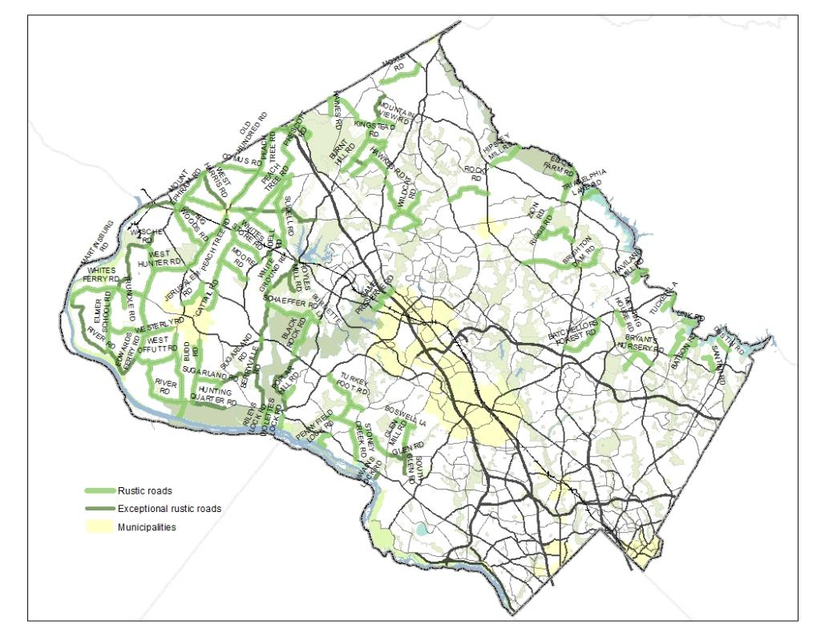
Map of Montgomery County’s Rustic Roads

The Basis of the Rustic Roads Program

In 1993, the Montgomery County Council established the Montgomery County Rustic Roads Program in order to preserve the rustic character of designated County roads. A rustic road is defined in the Rustic Roads Functional Master Plan as:

A road within the Agricultural Reserve or adjoining rural areas (areas where the majority of zoning is RDT, RC, or Rural) in Montgomery County, which enhances the rural character of the area due to its particular configuration, alignment, scenic quality, landscaping, adjacent views, or historic interest, and which exemplifies the rural and agricultural landscape of the County.

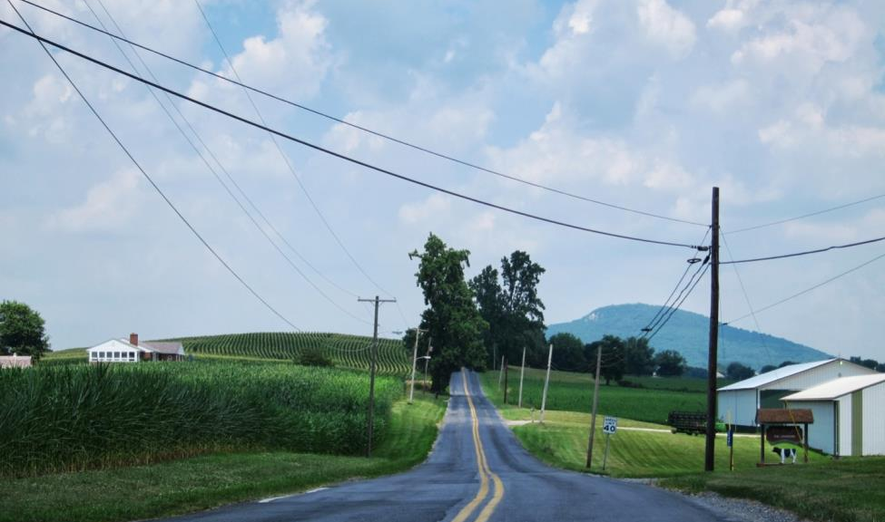
The significant features of Mount Ephraim Road include being a ridge road with expansive views and the alignment leading toward Sugarloaf Mountain, seen here.

Montgomery County Code, Chapter 49, Article 8 established the basis for the program and for the Rustic Roads Advisory Committee (RRAC). Following the enactment of the aforementioned code by the Montgomery County Council in 1993, Montgomery County Executive Regulation Number 21-96 – Rustic Roads was approved by the County Executive in 1996. This regulation provides guidelines for maintenance and improvements to the County’s rustic roads and is incorporated in the Code of Montgomery County Regulations (COMCOR) 49.79.01. Also, in 1996, The Maryland-National Capital Park and Planning Commission (M-NCPPC) adopted a Rustic Roads Functional Master Plan (RRFMP) which designated 66 roads in the County as rustic or exceptional rustic roads. Additional rustic roads have been added by area master plans in Clarksburg/Hyattstown, Cloverly, Damascus, Fairland, Great Seneca Science Corridor, Olney, Potomac and Sandy Spring/Ashton. There are now 97 roads that have been designated as either rustic or exceptional rustic roads.

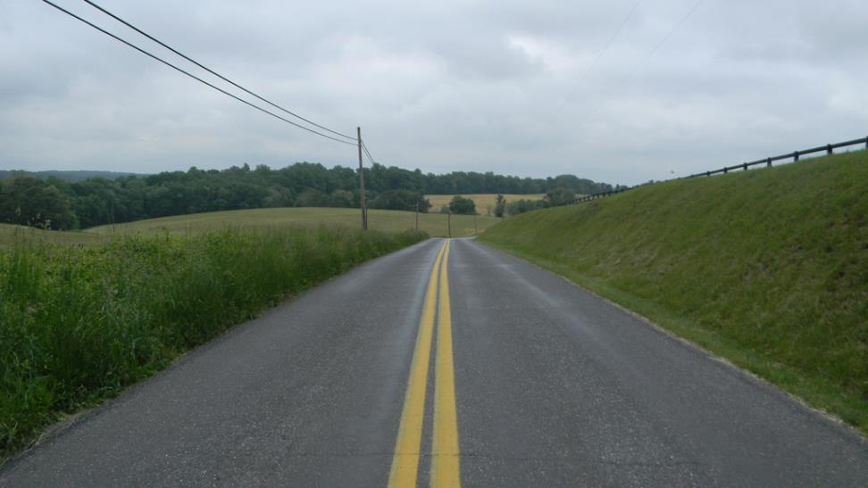
Comus Road is an example of a Rustic Road with “outstanding farm and rural vistas,” as they are described in the Rustic Roads Functional Master Plan.

Criteria

Montgomery County Code, Chapter 49, Article 8 gives criteria for both rustic and exceptional rustic roads. Specifically, the criteria for a rustic road are:
- The road is located in an area where natural, agricultural, or historic features are predominant, and where master planned land use goals and zoning are compatible with a rural/rustic character;
- The road is narrow and intended for predominantly local use;
- The road has a low traffic volume that does not detract significantly from the rustic character of the road;
- The road meets at least one of the following criteria:
  - It has outstanding natural features along its borders, such as native vegetation, stands of trees, and stream valleys;
  - It provides outstanding vistas of farm fields and rural landscapes or buildings;
  - It provides access to historic resources, follows historic alignments, or highlights historic landscapes.
- The history of vehicle and pedestrian accidents on the road in its current configuration does not suggest unsafe conditions.

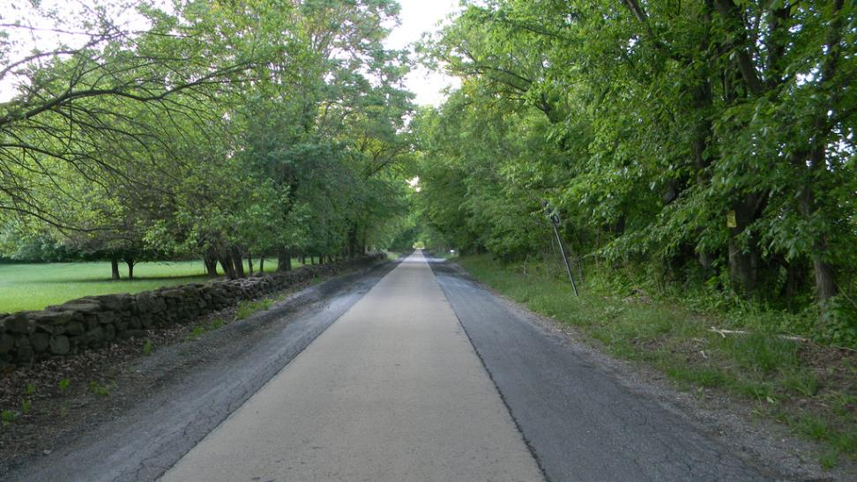
Martinsburg Road is an Exceptional Rustic Road. The well-preserved one-mile, one-lane concrete section, called a politicians road, is bordered by historic stone fences, and is designated in the Montgomery County Master Plan for Historic Preservation.

The criteria for an exceptional rustic road are:
- The road is a rustic road;
- It contributes significantly to the natural, agricultural, or historic character of the County;
- It has unusual features found on few other roads in the County;
- It would be more negatively affected by improvements or modifications to the road than would most other roads in the rustic roads program.

Rustic roads are designated by the County Council by approval of a Master Plan or an amendment to it. Most rustic roads are County maintained and many are located on prescriptive rights of way where the underlying land is owned by adjacent property owners. The County operates and maintains these roads within narrowly defined boundaries in order to allow for roadway drainage, signing, mowing, and tree maintenance. When a property along a rustic road is subdivided, the property owner is required to dedicate a right of way – usually 70 feet total width for a rustic road and 80 feet for an exceptional rustic road. These rights of way allow the County to protect a buffer along the roadside edge in addition to the road itself.

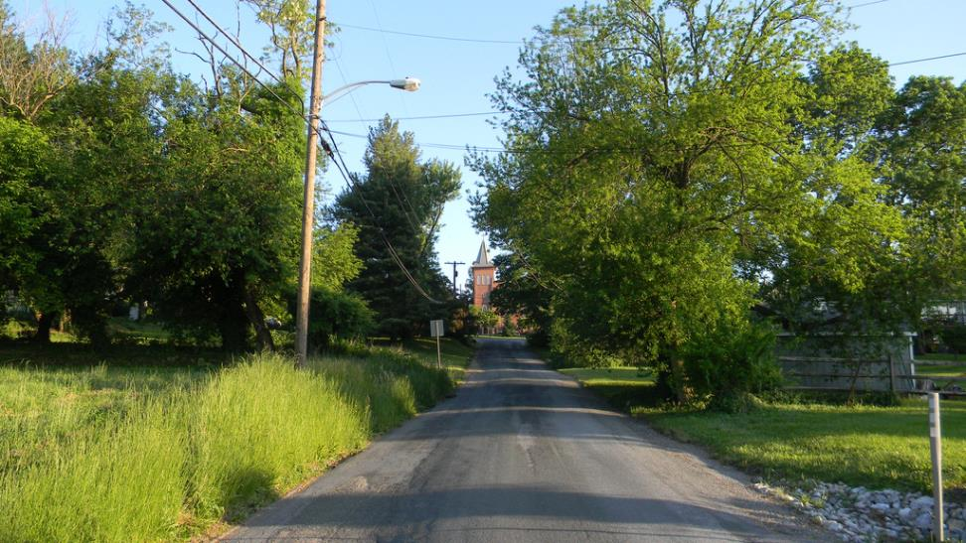
Rustic roads can have both scenic and historic vistas, as seen here on West Harris Road coming into the town of Barnesville.

Rustic Roads Advisory Committee

The Rustic Roads Advisory Committee provides oversight for the rustic roads program in an advisory capacity. The RRAC is comprised of seven voting members appointed for three-year terms by the County Executive and confirmed by the County Council. Montgomery County Code, Chapter 49, Article 8 charges the RRAC with the following duties:
- Promote public awareness and knowledge of the County rustic roads program;
- Review and comment on classification of rustic roads and exceptional rustic roads;
- Review and comment on Executive Regulations and other County policies and programs that may affect the rustic roads program;
- Report on June 1 of each even numbered year to the Executive, the Council, and the Planning Board on the status of the rustic roads program.

Additionally, per Montgomery County Code, Chapter 49, Article 8 and Montgomery County Executive Regulation 21-96, the Montgomery County Department of Transportation (MCDOT) looks to the RRAC for recommendations regarding matters that affect the County’s rustic roads. This includes improvements to rustic or exceptional rustic roads that are subject to the Development Approval Process. Montgomery County Code, Chapter 49, Article 8 also states: “When the Council classifies a road as a rustic road or an exceptional rustic road, the Council must identify the significant features of each such road that must be preserved when the road is maintained or improved.”

The RRAC meets at least six times per year to review and comment on proposals and to advise the appropriate agencies or parties on matters affecting rustic roads such as capital improvements, new developments, maintenance, road classification, and government policies or programs. The RRAC website is http://www.montgomeryplanning.org/community/plan_areas/rural_area/rustic_roads.shtm

Three agencies have primary responsibility for implementation of the rustic roads program in Montgomery County:
- The Montgomery County Planning Department of the Maryland-National Capital Park and Planning Commission (M-NCPPC). The Planning Department evaluates and recommends classification of rustic roads through Master Plans, reviews and approves development proposals along rustic roads, and maintains reference material, maps and a web-page for the program. The Chair of the Planning Board designates a member of the planning staff as a non-voting member of the RRAC.
- The Montgomery County Department of Transportation (MCDOT). MCDOT is responsible for roadway maintenance, traffic control and capital improvements such as bridge replacements. MCDOT also develops and recommends regulations, standards, and policies regarding rustic roads.
- The Montgomery County Department of Permitting Services (DPS). DPS reviews and permits work performed by private developers (e.g., driveways and utilities) within the right-of-way on rustic roads and ensures that significant features are preserved. DPS provides staff support to the RRAC and acts as a liaison for the rustic roads program with the above agencies and the public.

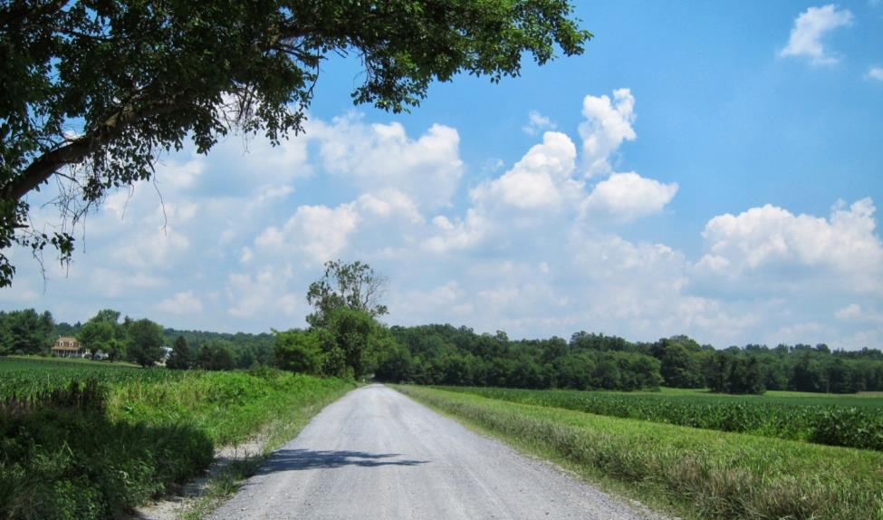
The unpaved section of River Road from Whites Ferry to Edwards Ferry Road is designated as an exceptional rustic road. The open views along the road are a significant feature. The C&O Canal Scenic Byway also follows River Road to Whites Ferry.

Two other agencies have limited areas of responsibility for rustic roads:
- The Maryland State Highway Administration (SHA). Two state roads are currently designated as rustic roads, namely Beallsville Road, Old Hundred Road (MD 109), and Frederick Road (MD 355) north of MD 109. In addition to these roads, the SHA has established a Maryland Scenic Byways Program which designates historic, cultural and scenic routes along state, local and park roads. Two scenic byways in Montgomery County are partially located along 18 rustic roads. These are the Antietam Campaign Byway and the Chesapeake & Ohio Canal Byway.
- The Montgomery County Department of Parks in the M-NCPPC. The Department of Parks is responsible for maintaining several rustic roads located within County parkland.

Program Summary

The Rustic Roads Program preserves the rustic character of certain County roads. Montgomery County Code, Chapter 49, Article 8 states “Each rustic road and exceptional rustic road must be maintained and improved in a manner that preserves the road’s significant features which the Council identified under subsection 49-78(d), but this requirement does not preclude improvements to promote safety or movement of farm equipment.”

As stated above, the Rustic Roads Advisory Committee is charged with reviewing and commenting in an advisory capacity on matters that affect the County’s rustic roads. In performing these reviews and making comments on proposed activities, the Committee is mindful of its charge from the County Council, of County Code and the Executive Regulations, and of the Rustic Roads Functional Master Plan.

In an effort to aid stakeholders and to improve its ability to provide consistency in its reviews and comments, the RRAC prepared a set of guidelines (see below) that deals with matters pertinent to the County’s rustic roads. It is important to recognize the distinction between the words “must” and “should” in reading these guidelines. When an item is required by Chapter 49, Article 8 of the Montgomery County Code or by Montgomery County Executive Regulation 21-96 or by the Rustic Roads Functional Master Plan, the word “must” is used and the course of action is automatically set. In essentially all other cases, some degree of subjectivity is necessarily involved, and the RRAC carries out its task by examining how the proposed action affects the impacted rustic road(s). The experience gained by the RRAC in dealing with many types of proposed actions is summarized in the guidelines.

The RRAC is pleased to work with all who are planning activities that impact Montgomery County’s rustic roads. Depending upon the type of project, the following items may be useful:
- A description of the project or proposal, including how it affects the road
- Plans
- Photos (preferably uncropped or retouched photos, taken at the equivalent to a 50 to70 mm focal length in a 35 mm format)
- Neighborhood petitions with a criteria checklist (for those wishing to nominate a road)
- Accident histories
- Balloon tests
- Field staking (for new roads or driveways)
- Sight distance measurements.
- Site visits

The RRAC’s staff coordinator places projects on the agenda, schedules site visits when needed, and can provide guidance for which items to provide for individual projects. Submittals should be in both paper and digital formats.

Rustic Roads Advisory Committee Guidelines

When to use the Guidelines

These guidelines should be consulted by anyone involved in planning, engineering, inspecting, or implementing any work within, adjacent to, or in the vicinity of the right-of-way of Montgomery County’s rustic and exceptional roads. The Rustic Roads Advisory Committee must advise the County Department of Transportation regarding the significant features of these roads that must be preserved when the roads are maintained or improved, or when a public utility completes work on or near the roads. (Montgomery County Code, Chapter 49, Article 8). This includes work on:
- New access points, e.g., streets and driveways
- Bridge replacements or alterations
- Guardrail installation
- Resurfacing
- Drainage reconstruction
- Lighting
- Special exception and mandatory referral filings
- Proposed improvements
- Major maintenance
- Tree maintenance
- Utility work

Approach to Work

Much like the Maryland Scenic Byways program (see Bibliography), the basic approach to work along a rustic or exceptional rustic road is to identify roadway characteristics, significant features and scenic views, and to determine appropriate actions to preserve, maintain and enhance these features.

General Principles

The rustic roads designation is not intended to keep the roads static. It does not prevent improvements to adjoining land or to the roads and bridges themselves. Maintenance on these roads is not to be neglected. Nor are improvements to promote safety or the movement of farm equipment precluded. Rather, reasonable care is to be taken to keep the roads compatible and in character with their agricultural and/or rural community and to protect the significant features that led to their designation.

Preserve significant features and limit modifications
When a road is classified as rustic, the County Council has identified the significant features of the road deemed to be outstanding and worthy of note that must be preserved. These significant features include, but are not limited to, stone walls, tree canopy, the view of a historic house, the road alignment, the road surface, hedgerows, etc. Also, particularly interesting and beautiful vistas from the road are identified as scenic views. These may include open views to Sugarloaf Mountain or shorter views to farm fields and stream valleys. The significant features for each road are identified in the RRFMP.

Physical modifications to roads are discouraged. However, they may be allowed when needed to provide adequate safety, to reduce maintenance problems, to accommodate farm equipment, or to achieve adequate sight distance. Physical improvements such as widening, adding guardrails or asphalt curbs, removing trees or foliage, or changing the vertical and horizontal geometry should be reviewed by the RRAC.

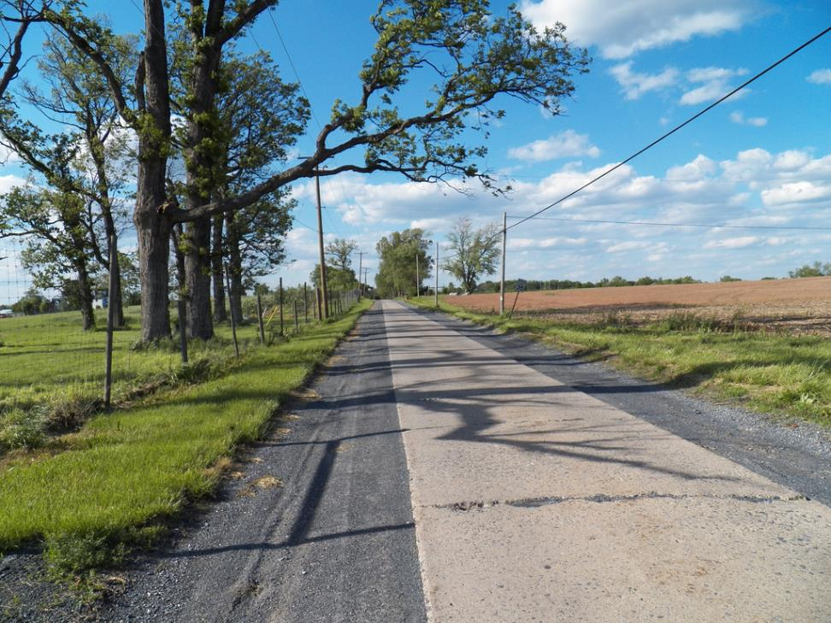
Proper maintenance of the historic concrete sections of the politicians’ road along Sugarland Road has helped protect this 1930s era pavement.

Maintain the roadway character
Maintenance of these roads should seek to maintain the roads’ rustic character and features. For example, maintenance of the concrete sections along Martinsburg and Sugarland Roads has been tailored to assure the longevity of these roads.

Enhance the roadway character
When a modification along a rustic road is proposed, consideration should be given to actions that can complement or enhance the road’s character such as using a gravel driveway instead of a paved driveway on an exceptional rustic road, replacing a galvanized guardrail with a timber guardrail, or removing excess pavement.

Share the road
Bicyclists, horseback riders and hikers often share these roads with residents, farmers, tourists, and commuters in cars, trucks and farm machinery. These are working roads which should function safely while preserving the rustic character of the roads for the use and enjoyment of all of the users on them.

Design Guidelines

The character of each rustic road is as individual as the history of each one and the landscape it travels through. The following guidelines are broken down in three parts according to location: The Roadway, The Edge, and The Land Beyond.

1. The Roadway

1.a. Alignments and geometry
The natural topographic characteristics of the roadway and how it fits into the landscape should be preserved to the maximum extent practical. Where documented safety problems are of a magnitude to justify changing the vertical or horizontal geometry, design techniques and materials must be compatible with adjacent unaltered portions of the road. Relocated sections must be designed to maintain compatibility with the connecting road segments and in general, should have similar width and surface.

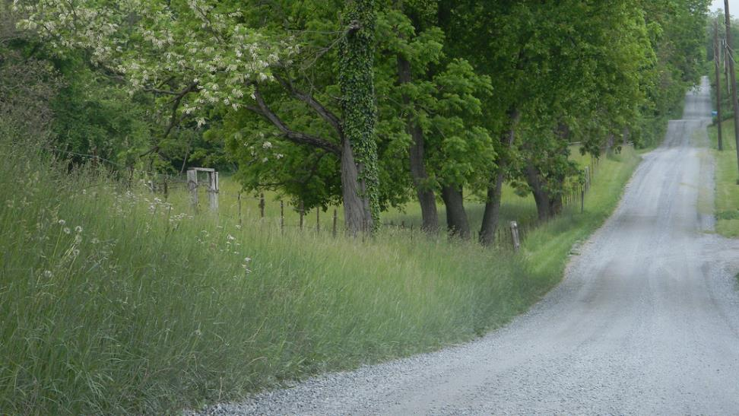
The gravel surface on West Harris Road near the town of Barnesville maintains the character of this historic farm wagon road.

1.b. Roadway surface
Some exceptional rustic roads have surfaces that are significant features. These include the type of pavement (i.e., gravel), single-lane concrete and, on one road, a water ford. These roadway surfaces must be preserved in so far as is possible and reasonable. However, preservation is not intended to mean inaction, but rather that maintenance or restoration techniques must respect the intrinsic nature of the road. Ideally, portions of concrete ribbon road that have been paved over with asphalt would be uncovered and restored. Periodic grading and dust suppression techniques are required for unpaved surfaces. Most rustic roads have been paved with asphalt over the years and require periodic maintenance. The recently used chip-seal treatment provided a more rustic appearance than smooth-seal asphalt, but good installation methods are needed to avoid loose gravel.

When roadways are resurfaced, care must be taken not to indiscriminately widen the road. If a roadway has been inadvertently widened beyond the widths recorded as roadway features in the RRFMP, the excess pavement should be removed so as to maintain the rustic character of the road and to avoid creating drainage problems from additional impervious area.

Where concrete roadways have deteriorated, repairs should be made. Full replacement of the concrete roadway should only be undertaken as a last resort when repairs cannot feasibly be made. The concrete portion of Martinsburg Road is designated in the Master Plan for Historic Preservation; any proposed alterations are subject to review and approval by the Historic Preservation Commission. Contact historic preservation staff early in the planning process to discuss project scope of work.

1.c. Pavement cutting and utility work
Repair and restoration of a rustic road must be made to all damaged pavement and edges within the public right of way. These repairs must be made in accordance with the approved plans and as directed by Montgomery County’s Department of Permitting Services.
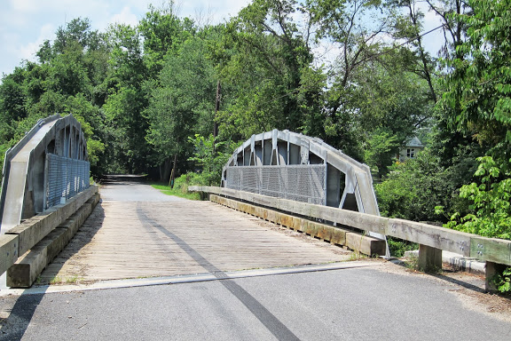
This replacement bridge at Mouth of Monocacy Road over the CSX railroad follows the profile of a pony truss, and is sympathetic to its rustic surroundings.

1.d. Bridges and culverts
Any improvements of bridges on rustic roadways must be done in such a way as to preserve or enhance the character defining features of the structure. When possible, rehabilitation of the bridge is preferred over replacement. Railings that have deteriorated should be stabilized or rebuilt with elements of the same appearance. A rustic design such as steel-backed timber guardrails may also be appropriate.

To the extent feasible, bridge rehabilitation should attempt to maintain or replicate the scale and character of the existing bridge or culvert that is visible from the roadway.

If a bridge or small structure is considered a significant feature of the rustic road, it should be preserved through maintenance and repair. When a bridge must be replaced, compatibility can be achieved by replacing the structure with a similar design so that the scale and materials are similar to the previous structure. If, however, the existing bridge is of a style that detracts from the road character, or environmental, economic or safety reasons require a different design, a replacement bridge can enhance the rustic road by selecting a design that complements the rural or historic landscape.

The width of the bridge deck and the approach road geometrics on replacement bridges on rustic roads must accommodate emergency vehicles and farm equipment but should be compatible with the existing roadway width. On exceptional rustic roads, the new bridge deck width must be no wider than the existing deck unless necessary for farm equipment. In this case the bridge deck should not be wider than the existing approaches.

Bridge abutments visible from the road or from trails below the road should be designed to be visually compatible with the rock types and soil color of the adjacent stream bank or other embankment.

1.e. Grading and drainage
With few exceptions, rustic roads do not have engineered drainage ditches. Generally, storm water flows across the adjacent land and infiltrates naturally. However, adequate drainage is vital for the maintenance and safety of the road. Thus, grading and drainage should be undertaken in a manner that reinforces the existing character of the roadway. Precisely engineered swales or slopes should be avoided on rustic roads. Where improvements are required, drainage swales or slopes should look like they are a part of the natural landscape. In doing this, paving should be avoided. Where curbing is needed to direct roadway drainage, asphalt rather than concrete should be used.

1.f. Driveways and intersections
See section 2.a. below.

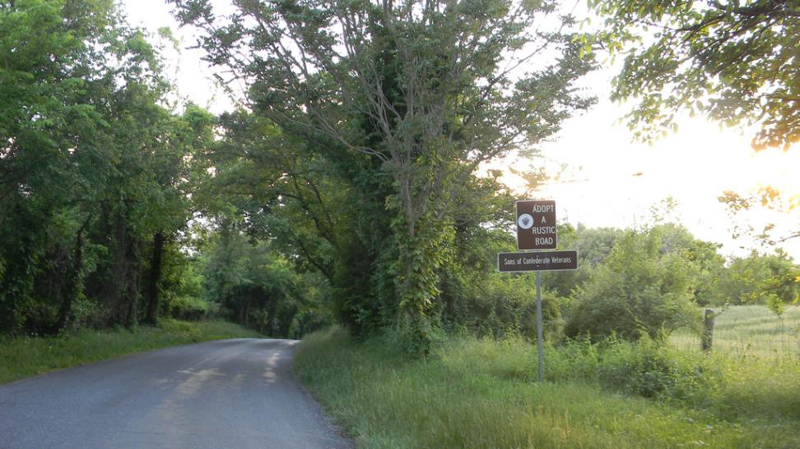
Subtle, brown signs fit with the character of this section of Martinsburg Road near Wasche Road.

1.g. Signs and markings
Signs and markings must follow the Manual on Uniform Traffic Control Devices (MUTCD). However, a practice of “the least control is the best control’ should be followed so that sign clutter does not overwhelm the visual character of the natural landscape. Where the average daily traffic is less than 400 vehicles per day, signs and markings should follow the guidelines in part 5 (“Traffic Control Devices for Low Volume Roads”) of the MUTCD. The minimum sign sizes should be used whenever possible.
Brown signs with white lettering, such as the 2012-approved street name signs on rustic roads, and the Adopt A Rustic Road signs, fit the character of rustic roads. The color of the sign posts and the back of signs should also be compatible with the rural environment.

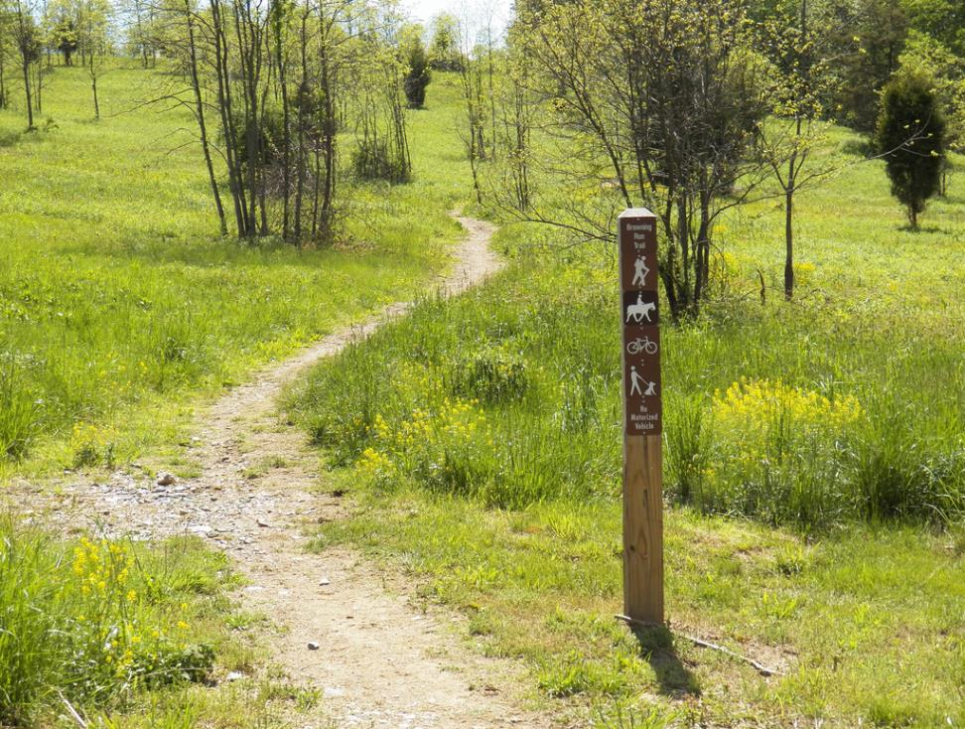
A brown trail sign for Browning Run Trail in Little Bennett Park.

1.h. Bikeways
Due to their low volume of traffic and scenic nature, the rustic roads are very popular for bicyclists, who often ride in groups or in clubs who prefer a long distance network. This is reflected in the Countywide Bikeways Functional Master Plan which designates several rustic roads as signed shared roadways. Bicycle use of the rustic roads should be encouraged and protected as it provides an excellent way to enjoy the beauty of the Agriculture Reserve.

All users need to recognize that bicycles are a legitimate roadway vehicle and understand how to properly share the road with cyclists. Bicyclists have rights-of-way and the same duty to obey traffic signals as motorists. But bicycles are less visible, quieter, and don’t have a protective barrier around them. The driver of a vehicle passing another vehicle, including a bicycle, must pass at a safe distance and leave plenty of space. The driver must be able to see the vehicle that has been passed in the rear view mirror before returning to the original lane. After passing, the driver must make certain that his vehicle is clear of the bicyclist before making any turns. The driver of a vehicle must not pass any closer than three (3) feet to a bicycle.

The needs of bicyclists should be considered when making alterations or improvements to rustic roads. Countywide bikeway routes should be signed to guide cyclists and to alert other users to their presence, and warning signs should be placed in areas where conflicts are observed.

1.i. Curbs and gutters
Concrete curbs and gutters are inappropriate on rustic roads. However, where sections of concrete barrier curb are required, such as to protect a sidewalk, the color of the concrete should blend well with the surrounding environment.

1.j. Auxiliary lanes
The land use associated with rustic roads would typically not generate traffic volumes that would justify deceleration, acceleration, or separate turn lanes. These additional lanes should never be provided on exceptional rustic roads. On rustic roads, auxiliary lanes may be considered in unique situations only if justified by a traffic safety study approved by MCDOT.

1.k. Shoulders
Shoulders should be composed of turf or gravel. Where required for safety or to prevent erosion, minor paving may be considered.

2. The Edge

2.a. Driveways and intersections
The number of new driveways and intersections should be minimized. They must be sited to avoid disturbance to significant features and trees and mature hedgerows. Driveways should be consolidated where possible. Shared driveways that serve a number of homes are preferred over public streets as they are significantly narrower and create less visual intrusion. Driveway widths should typically be in the range of ten to 12 feet. For shared driveways where the fire marshal requires a wider width (20 feet), care must be taken to site or screen the driveway so it has the least visual impact on the road.

Sight distances for new driveways, intersecting roadways and safety improvements must meet the minimum standards recommended by AASHTO. While the minimum sight distance is 150 feet, a greater length may be required based on actual roadway operating speeds. In order to preserve the rustic character of the road, trees and other features altered to provide safe sight distances may need to be restored outside the line of sight.

In general, most driveways will be asphalt. However, gravel driveways are permitted on exceptional rustic roads where existing adjacent or nearby driveways are gravel. Also, special paver driveways may be allowed.
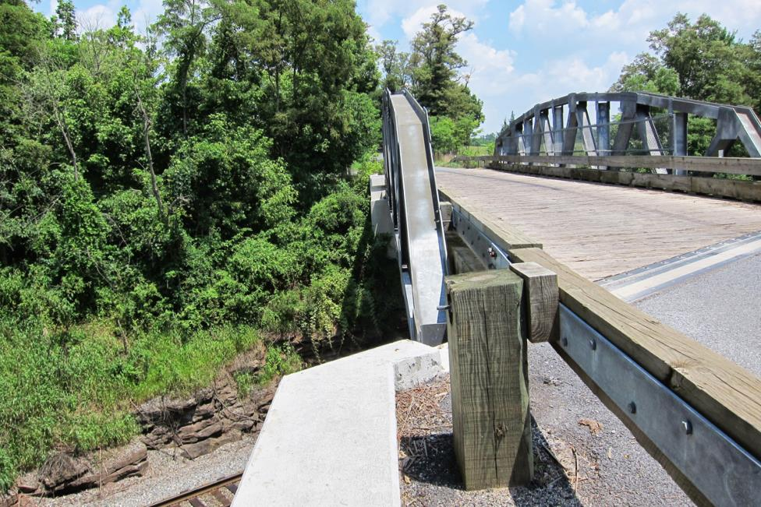
Steel-backed timber guardrail used on the Mouth of Monocacy Bridge.

2.b. Guardrails
Less visually intrusive guardrails, such as those made of steel-backed timber, are recommended along rustic roads, rather than galvanized metal guardrails.

2.c. Signs in the right-of-way
See section 1.g above (“Signs and markings”).

2.d. Speed cameras, utility boxes, etc.
The visual impact of traffic related devices (e.g., speed cameras, utility boxes, etc.) or other equipment that are installed on rustic roads should be reduced by specifying dark colors for the equipment.

2.e. Pedestrians and hikers
There are few sidewalks along rustic roads, so pedestrians and hikers use grass shoulders or the edge of the pavement. These users should walk facing traffic, and drivers should be watchful for their presence.

Adding new paved sidewalks or trails along rustic roads is not consistent with the County’s Context Sensitive Road Design Standards; however, there may be locations where natural surface trails along the road would be appropriate. Any such proposal should be referred to the RRAC for review.

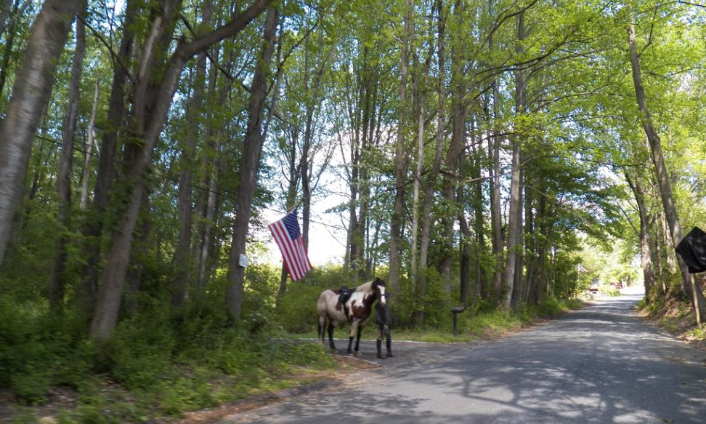
Horses, pedestrians, bicyclists, and farm equipment all share the rustic roads with automobiles and trucks.

2.f. Equestrian users and equestrian trail crossings
Horses have the right of way. Equestrian trail crossings on rustic roads should be well marked. Signs should be in accordance with section 1.g (“Signs and markings”). The road edge and shoulder should be in accordance with the section on “Road edge and shoulders” (in section i below).

2.g. Parking
Rustic roads are generally too narrow to allow parking but it can be allowed where safe. Small pull-off areas (not parallel) for parking, such as a stabilized, gravel area, may be appropriate at trail heads, scenic views, or historic sites. The RRAC will review requests on a case-by-case basis.

2.h. Street trees
Trees along rustic roads should reflect the rural and agricultural nature of the area. On some rustic roads, formal hedgerows were planted many years ago, and they have matured into distinctive features of the roads. The most common ones are rows of Eastern Red-cedars (our native Juniperus virginiana). Native locust and sycamore trees have also been planted.

At the time of subdivision, planting trees along the road may be required. Formal hedgerows, such those described above, may be provided, or informal clumps of native trees may be plants. Lower-growing trees should be planted in the presence of overhead power lines. MCDOT maintains a list of approved street trees, and the RRAC is available for review of plant selection and planting designs.

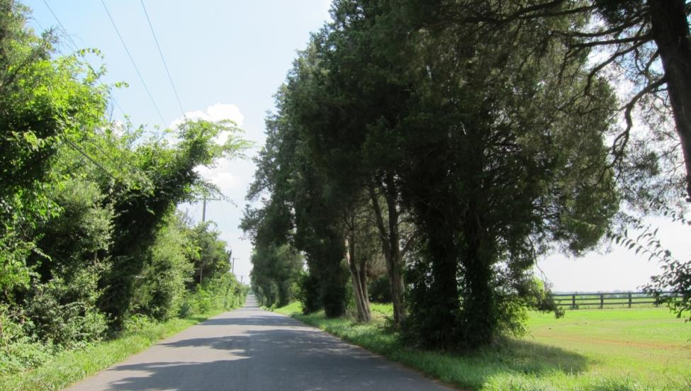
Eastern red cedar hedgerows have traditionally been planted along many roads (Hughes Road is shown above).
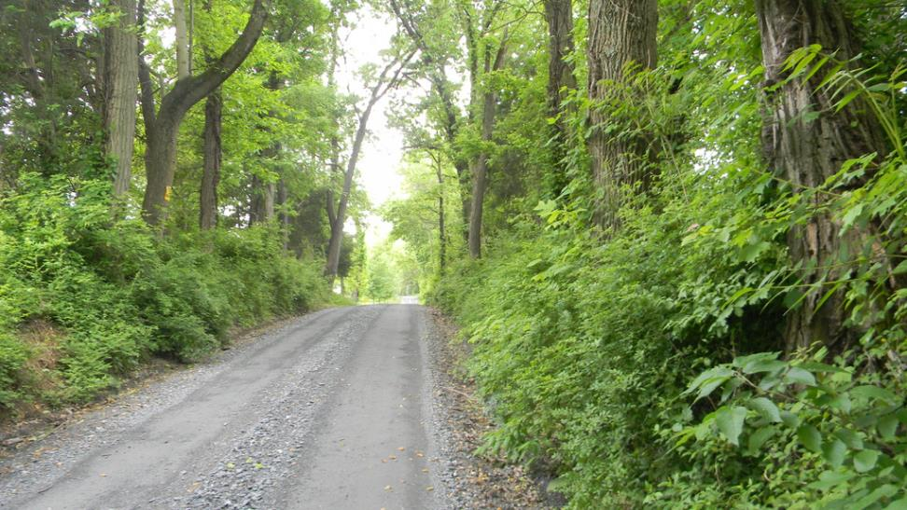
Hedgerows and tree canopy along West Harris Road.

2.i. Informal hedgerows
Many rustic roads are characterized by sections lined by informal hedgerows, often along a fence line or field edge. While there are some well-maintained hedgerows as discussed above, many are simply an over-growth of young trees, vines and invasive plants that have grown through neglect and lack of maintenance. A distinction should be made between hedgerows by design and hedgerows by neglect. The overgrowth along a road often creates an impenetrable visual barrier between the rustic road and the agricultural/historical elements that give the road its character – views of farm fields, scenic vistas and historic buildings. The overgrowth also creates driving impediments, particularly to farm vehicles. Hedgerows with mature trees should be preserved where possible, while those with damaging vines or invasive plants should have undesirable vegetation removed.

2.j. Maintenance of roadside foliage and trees
In order to protect the natural beauty of Montgomery County’s rustic and exceptional rustic roads, the RRAC recommends the following:

Significant features. Where roadside foliage and trees are listed as significant features of a rustic road, they should be maintained in good condition, and consideration should be given to enhancing the feature.

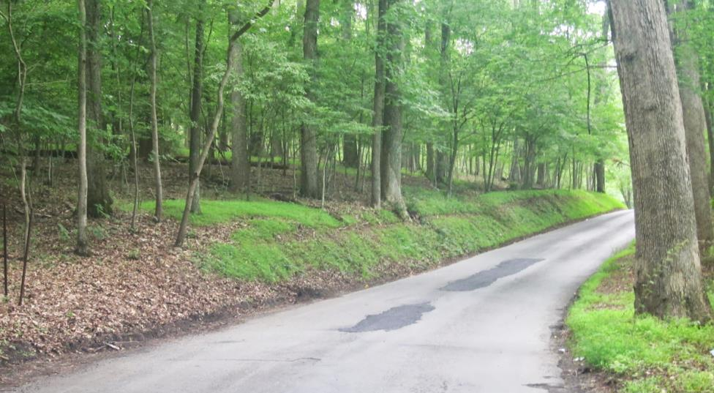
The mature woodlands on Davis Mill Road are a significant feature of the road.

Road edge and shoulders. Grass mowing and foliage removal may be performed within six feet of the edge of pavement or 16 feet from the centerline of the road for roads less than 20 feet in width, within prescriptive easements. Maintenance activity should protect desirable vegetation adjacent to a rustic or exceptional rustic road.

Desirable vegetation. Forests, established natural fence lines and mature hedgerows should be preserved, even if there are non-native species intermixed. Invasive species are generally not considered to be desirable vegetation. Designated noxious weeds must be managed.

Tree canopy. The tree canopy should remain as undisturbed as possible while permitting the passage of cars and light trucks. On roads where the movement of farm equipment necessitates it, limbs and overhanging foliage should be trimmed up to a height of 16 feet measured at the edges of the pavement.

Tree removal. Removal of trees not dead or diseased should be reserved only for safety reasons.

Evergreens. Avoid single-sided maintenance where unnatural forms are created.

Utility pruning and removal of trees and vegetation. Pruning of utility lines along rustic roads should be done selectively, while preserving the character of the roads, as well as their significant features. Pruning should be done in accordance with International Society of Arboriculture Best Management Practices and this section on Maintenance of roadside foliage and trees. The pruning should leave no foot print and all debris should be removed. All obsolete utility poles should be removed as soon as possible.

Notification. The RRAC should be notified at least 30 days in advance of routine or utility maintenance on a rustic road, or maintenance scheduled to address safety issues such as sight distance. This will allow the committee time to offer guidance on desirable vegetation features for the specific road. The DPS staff member who supports the RRAC should be contacted (see inside front cover).

Priorities. Roads needed for the passage of farm equipment should receive maintenance on a priority basis. The RRAC will provide a list of these roads upon request.

3. The Land Beyond

3.a. Views and vista
The Purpose clause for the Rustic Roads Program reflects the importance of the scenic quality of the rustic roads: “This Article establishes a program to preserve as rustic roads these historic and scenic roadways that reflect the agricultural character and rural origins of the County.”

Although there are a variety of views and vistas from the many Rustic Roads, their natural features, viewsheds, farms, historic landmarks, and other important features serve to define the nature of a rustic road. Within the context of specific parameters set by these design guidelines, the viewshed should be preserved to the greatest extent possible. Furthermore, any proposed plans, such as radio towers, commercial buildings, and others, should strongly consider the integrity of the historic viewshed, as any disturbance or breakup of such viewsheds significantly impacts the value and significance of the rustic roads that are affected.
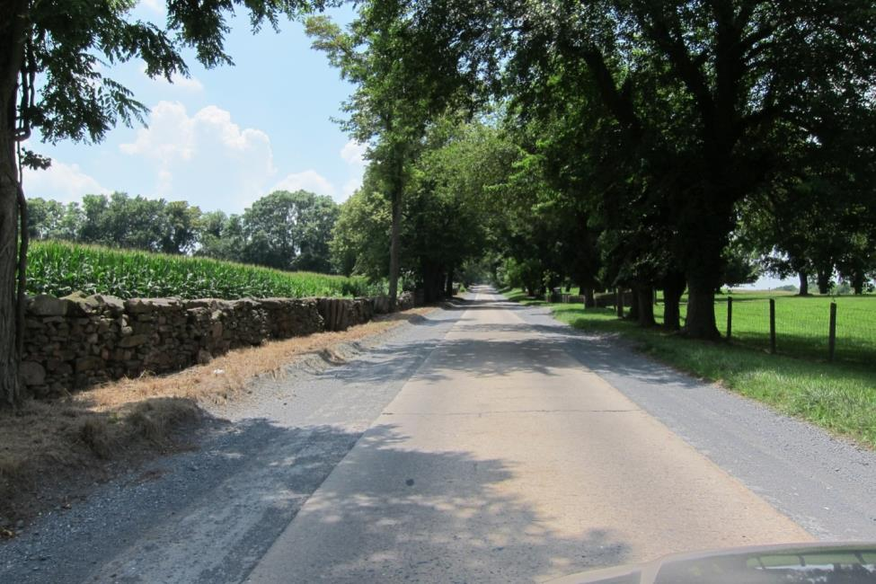
The historic wall and the fences and entry features along Martinsburg Road contribute to the character of the road; they are within the recommended 80-foot right of way.

3.b. Walls, fencing and mailboxes
Walls and fences along rustic roads are typically private and, where a right of way has been dedicated, they should, in general, be located outside the right of way. New walls and fences should be consistent with the scale and character with those generally found on a rustic road.

Mailboxes are regulated by the United State Postal Service and by the Department of Permitting Services. The County Code requires that they be mounted on a support that will bend or break away on impact by a vehicle. Due to both safety and aesthetic considerations, monumental mailboxes are inappropriate on rustic roads.

3.c. Entry signs or features
Subdivision identification signs or similar features are generally not in keeping with the character of rustic roads. If one is needed because a street sign cannot be seen, the RRAC will review the proposed design. There should be no illumination of signs or features.

3.d. Private signs
Signage should be consistent with the character of the roads and not detract from their rustic nature. Signs should not be lighted.

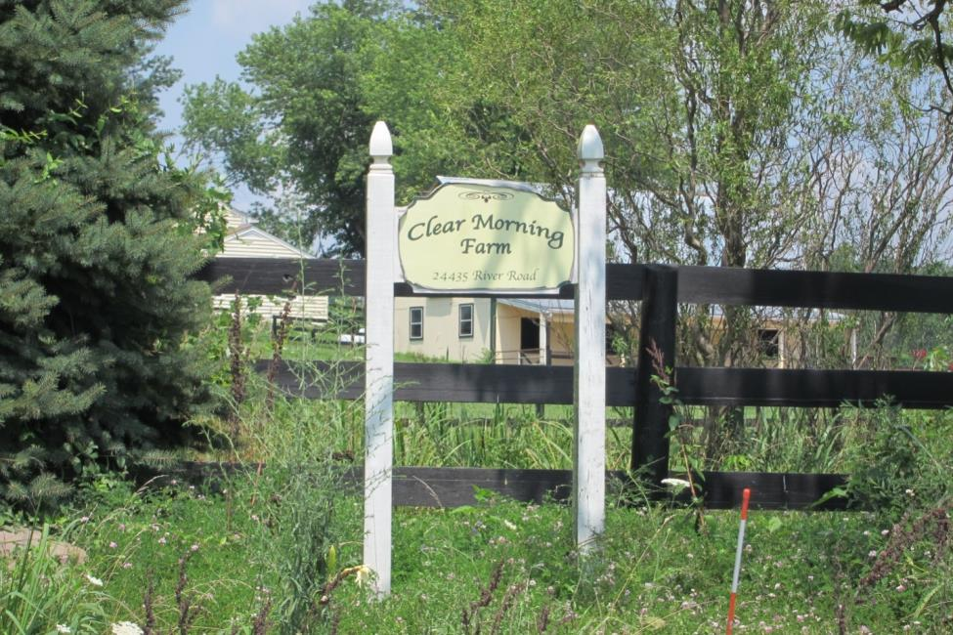
A wooden sign marks a farm on River Road near Whites Ferry.

3.e. Screening
Typically the rights of way along rustic roads should remain undisturbed and in their natural state except for drainage, maintenance, tree maintenance, mowing, or clearing of overgrowth. However, in some circumstances, it may be desirable to require the planting of additional trees or shrubs to provide for the screening of new or modified development. In these cases, the use of typical street trees with regular spacing is generally out of character with the rustic road. Instead, native trees and shrubs grouped naturalistically may be more appropriate. Native trees from the MCDOT-approved tree list are usually preferred by the RRAC.

3.f. Cell towers, windmills, and wind turbines
In order to maintain the rural nature of a rustic road, the location of cell towers, windmills and wind turbines need to be evaluated relative to their location to a rustic road.

The Rustic Roads Advisory Committee reviews proposed cell tower, windmill and wind turbine locations to assess their impact on the rustic character of the road and potential impact on views. Suggested locations include those where these structures cannot be seen from the rustic road or are only partially visible. Additionally, using existing structures or using designs that allow these structures to blend into the environment is preferred.

Abbreviations

AASHTO American Association of State Highway and Transportation Officials
COMCOR Code of Montgomery County Regulations
DPS Department of Permitting Services
MCDOT Montgomery County Department of Transportation
M-NCPPC The Maryland-National Capital Park and Planning Commission
MUTCD Manual on Uniform Traffic Control Devices
RRAC Rustic Roads Advisory Committee
RRFMP Rustic Roads Functional Master Plan
SHA Maryland State Highway Administration

Bibliography

Cited references

Best Management Practices: Utility Pruning of Trees. ANSI A300. International Society of Arboriculture, Champaign, Illinois. 2004.

Code of Montgomery County Regulations (COMCOR) 49.79.01. Rustic Roads. Montgomery County, Maryland, 1994.
http://amlegal.com/nxt/gateway.dll/Maryland/comcor/chapter49streetsandroads-regulations?f=templates$fn=default.htm$3.0$vid=amlegal:montgomeryco_md_mc$anc=JD_49.79.01

Context Sensitive Solutions for Work on Maryland Byways. Maryland State Highway Administration, February 2008. http://www.marylandroads.com/OED/CSS-3.pdf

Countywide Bikeways Functional Master Plan. Montgomery County, Maryland. March 16, 2005.
http://www.montgomeryplanning.org/transportation/bikeways/A_A/contents.shtm

Manual on Uniform Traffic Control Devices for Streets and Highways - 2009 Edition. U.S. Department of Transportation, Federal Highway Administration, 2009.

Maryland Department of Transportation – Current Bicycle Laws. Maryland Department of Transportation – Motor Vehicle Administration, 2010.
http://www.mva.maryland.gov/Driver-Safety/Bicycle/default.htm

Maryland Scenic Byways, Maryland Department of Transportation, Office of Environmental Design, State Highway Administration. http://www.marylandroads.com/index.aspx?Pageid=97

Montgomery County Code, Chapter 49, Article 8. Rustic Roads Program. Montgomery County, Maryland, 2008.
http://www.montgomeryplanning.org/community/plan_areas/rural_area/documents/RusticRoadsCh49Article8.pdf

Montgomery County Context Sensitive Road Design Standards. Montgomery County, Maryland. December 9, 2008.
http://www.montgomeryplanningboard.org/agenda/2008/documents/20080918_attachments_road_code.pdf

Montgomery County Executive Regulation Number 21-96 - Rustic Roads. Montgomery County, Maryland. November 26, 1996. See appendix 2.
http://www.montgomeryplanning.org/community/plan_areas/rural_area/documents/RusticRoadsExecReg21-96.pdf

Rustic Roads Functional Master Plan. The Maryland-National Capital Park and Planning Commission. Silver Spring, Maryland. 1996.
http://www.montgomeryplanning.org/community/plan_areas/rural_area/master_plans/rustic_roads/rustic_toc.shtm

Rustic Roads Advisory Committee website. Montgomery County Planning Department, Maryland.
http://www.montgomeryplanning.org/community/plan_areas/rural_area/rustic_roads.shtm

Tree Maintenance. Montgomery County Department of Transportation, Division of Highway Services. http://www.montgomerycountymd.gov/DOT-Highway/Tree/index.html

Additional references

A Policy on Geometric Design of Highways and Streets. 6th edition. American Association of State Highway Transportation Officials, Washington, D.C., 2011.

Design Guide for Rural Roads. Dutchess Land Conservancy, Dutchess County, New York, 1998. http://dutchessland.org/books.htm

From Milestones to Mile-Markers: Understanding Historic Roads. Paul Daniel Marriott. America’s Byways Resource Center, Washington, D.C., 2004.

Greenway Connections. Planning Department, Dutchess County, New York. (see Greenway Guides, Rural Roads, 2010.) http://www.co.dutchess.ny.us/CountyGov/Departments/Planning/17334.htm

New Jersey Historic Roadway Study. New Jersey Department of Transportation, January 2011.
http://www.state.nj.us/transportation/publicat/historicroadwaystudy.pdf

Rural Road Design, Maintenance, and Rehabilitation Guide. South Dakota Department of Transportation, September 1995.
http://www.sdstate.edu/engr/ltap/upload/SD95-16-G2-Rural-Rd-Design-Maint-Rehab-Guide.pdf

Rural Road Standards: Design Standards and Policies for Rural Baltimore County Roads. Baltimore County, Maryland, May 2008. http://www.thevpc.org/wp-content/uploads/2010/12/RuralRoadsAdopted.pdf

Toolkit for Historic Roadways. New Jersey Department of Transportation, August 2011.
http://www.state.nj.us/transportation/publicat/toolkitforhistoricroadways.pdf

Vermont State Design Standards . Vermont Agency of Transportation, October 1997.
http://vtransengineering.vermont.gov/sites/aot_program_development/files/documents/publications/VermontStateDesignStandards.pdf

Virginia Rural Rustic Road Program Manual. Virginia Department of Transportation, July 2012.
http://www.virginiadot.org/info/resources/RuralRusticProgram.pdf

Wisconsin Rural Bicycle Planning Guide. Wisconsin Department of Transportation, April 2006.
http://www.dot.wisconsin.gov/projects/state/docs/bicycle-rural-guide.pdf

Appendices

Appendix 1: Chapter 49, Article 8 of the Montgomery County Code

Appendix 2: Montgomery County Executive Regulation 21-96

References are given in full in the bibliography (see page 23). All URLs cited in this document are valid as of the date shown above.
Abbreviations are summarized on page 13. Here, the RDT and RC zones refer to the Rural Density Transfer and the Rural Cluster zones.
The 1996 Master Plan definition (p. 3) was taken from what was originally named a “rural road” in the March 1990 Task Force report, Proposal for a Rural/Rustic Roads Program (p. 2).
See Appendix 1.
See Appendix 2
Sec. 49-78 (b) and (c). A brief description of each of the criteria for rustic and exceptional rustic roads is found in the 1996 RRFMP, pp. 37-40.
Sec. 49-80 (e)
Sec. 49-78 (d)
RRFMP, p. 3
http://www.montgomeryplanning.org/transportation/bikeways/A_A/contents.shtm
http://www.mva.maryland.gov/Driver-Safety/Bicycle/default.htm
http://www.montgomeryplanningboard.org/agenda/2008/documents/20080918_attachments_road_code.pdf
Best Management Practices: Utility Pruning of Trees. ANSI A300. International Society of Arboriculture, Champaign, IL. 2004.
Montgomery County Code, Chapter 49, Article 8. Rustic Roads Program, Sec. 49-76. Purpose.
https://www.usps.com/manage/know-mailbox-guidelines.htm
http://www.montgomerycountymd.gov/DOT-Highway/Tree/index.html

